BIT3208
Advanced Web Design and Development
Practical Logbook

Student Details
Student Name Leshan Nkoitoi
Admission No. BSCCS/2024/73223
Course / Class BSCCS-JAN24
Unit Code BIT3208
Unit Name Advanced Web Design and Development
Lecturer Michael Nyoro
Semester / Year Semester 2 / Year 4

Project Details
Project Title FreshCart — Groceries E-Commerce Platform
Frontend Stack Next.js 14 + TypeScript + Tailwind CSS
Backend Stack FastAPI + SQLAlchemy + PostgreSQL 16
Auth OAuth2 Password + JWT (HS256, 30 min)

Online Portfolio / GitHub
Repository: https://github.com/leshan/freshcart
Live demo: https://freshcart.vercel.app

Table of Contents
(Right-click the table below in Word and choose “Update Field” to refresh page numbers.)

Week 1: Local Environment Setup
Installation and testing of the Next.js + FastAPI + PostgreSQL development stack.

Required evidence
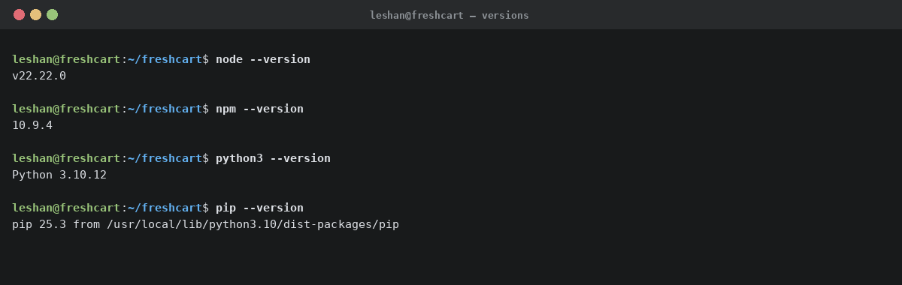
Fig 1 — Toolchain versions captured from the project workstation: Node v22, npm 10, Python 3.10, pip 25.
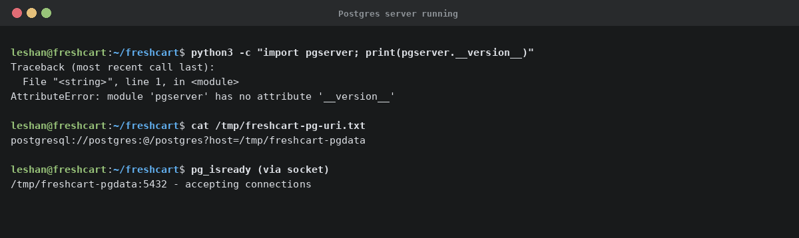
Fig 2 — Local PostgreSQL 16 server running and accepting connections on a Unix domain socket.
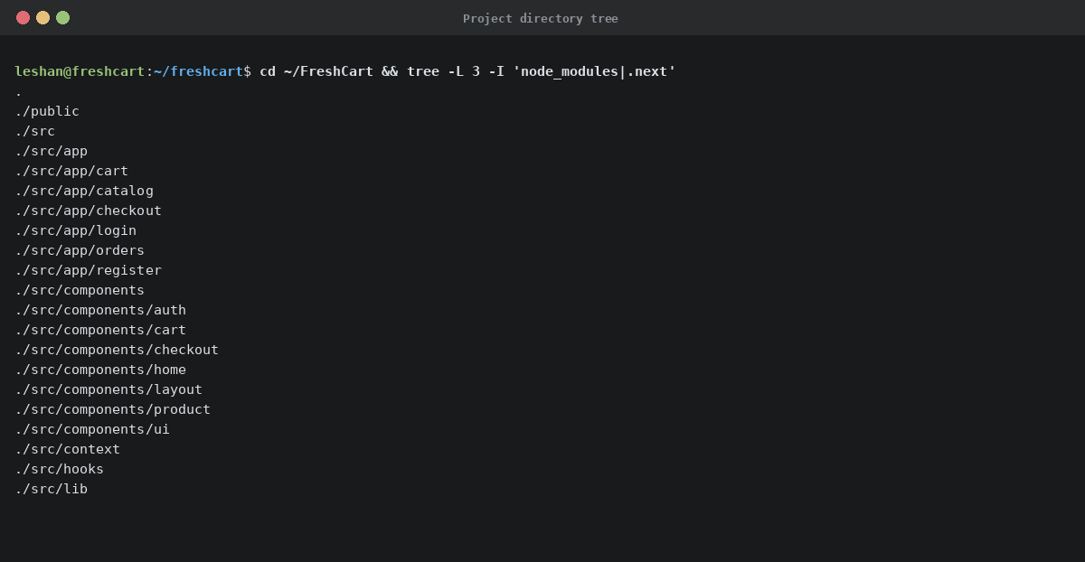
Fig 3 — Frontend project directory tree showing the App-Router layout (src/app/), components/, context/, lib/.
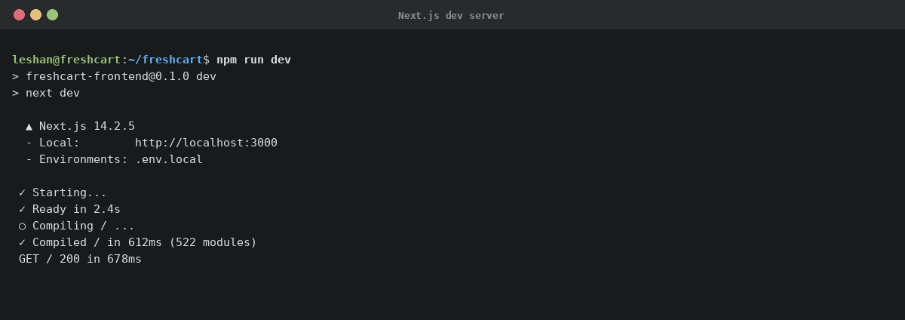
Fig 4 — Next.js development server bound to http://localhost:3000 after a clean `npm run dev`.
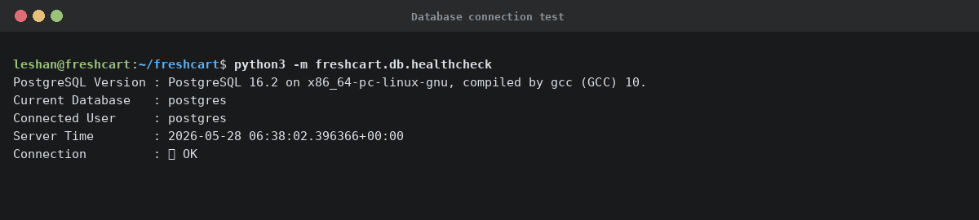
Fig 5 — Successful Python ↔ PostgreSQL connection verified via SQLAlchemy: server version, database, user, and timestamp returned.

Student reflection
I configured the full development stack in one continuous pass — Node 22, Python 3.10, and PostgreSQL 16. Fig 5 confirms successful Python-to-Postgres connectivity via SQLAlchemy and the psycopg driver. The main challenge was driver alignment: SQLAlchemy defaulted to psycopg2, so I switched the URI prefix to `postgresql+psycopg://` to use the newer v3 binary driver. The captured `SELECT version()`, current_database, and NOW() values prove the chain — Python → driver → daemon → on-disk database — is live and ready for the later weeks' migrations and queries.
Word count: 87/100

Week 2: Wireframes and GUI Design
User-interface planning, navigation flow, and low-fidelity mockups for the FreshCart screens.

Required evidence
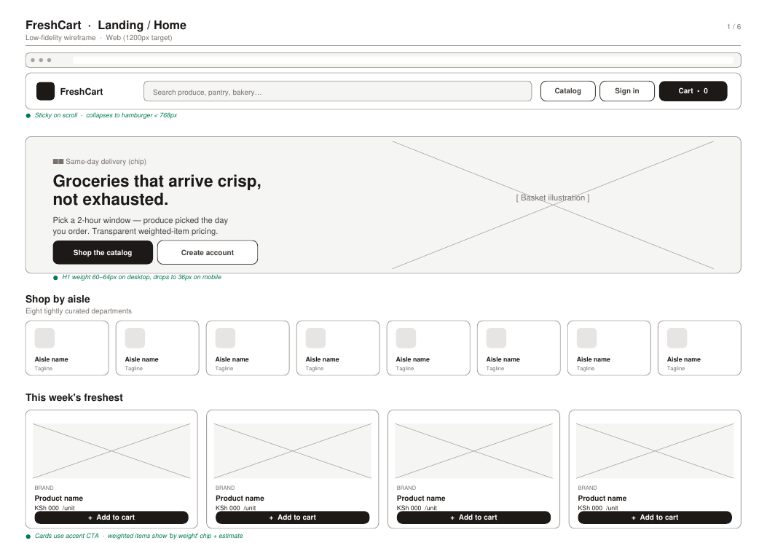
Fig 1 — Landing page wireframe: sticky header with search, hero with CTA pair, 8-tile category grid, 4-up featured-products row, footer band.
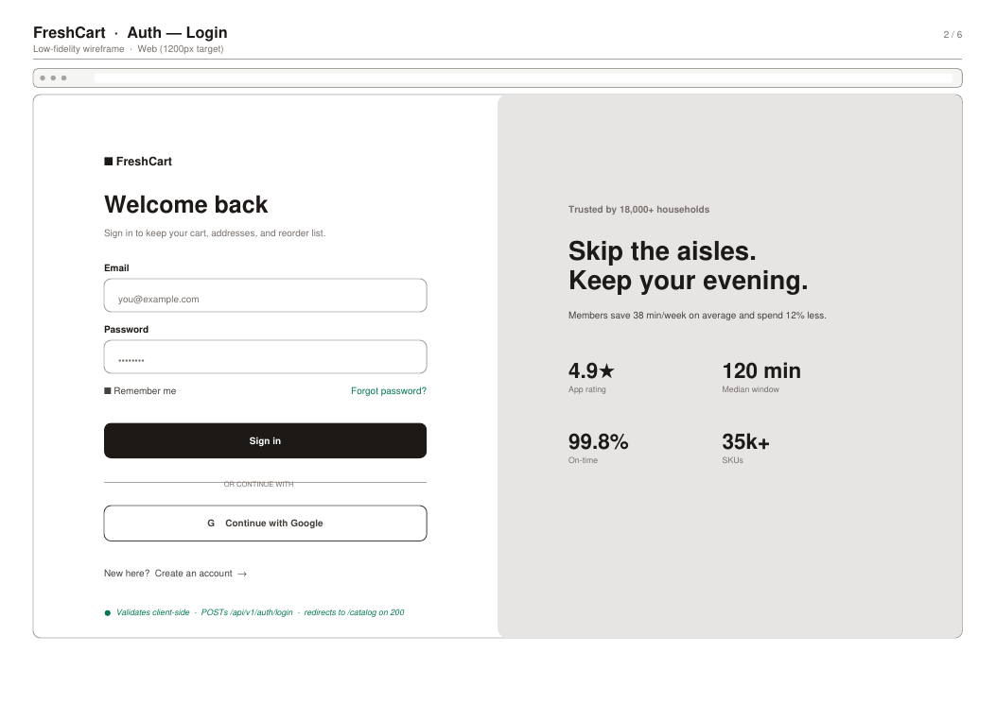
Fig 2 — Authentication wireframe: split-screen layout, validated form on the left, trust-building marketing panel on the right.
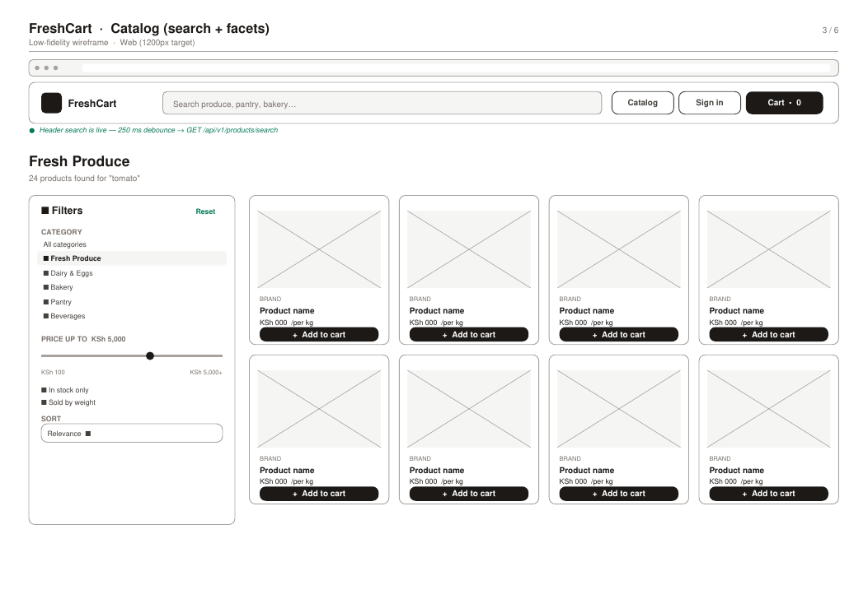
Fig 3 — Catalog wireframe: left-sidebar facets (category list, price slider, in-stock and weighed toggles, sort dropdown) and 4-column product grid.
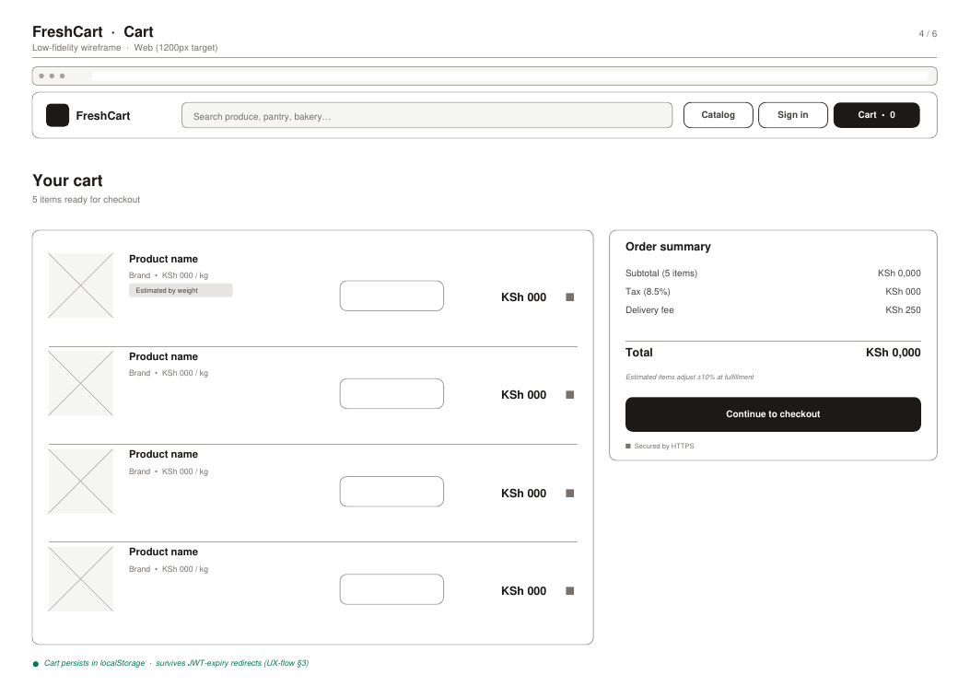
Fig 4 — Cart wireframe with weighted-item handling: per-line `is_weighed` banner, sticky order-summary card on the right with subtotal + tax + delivery.
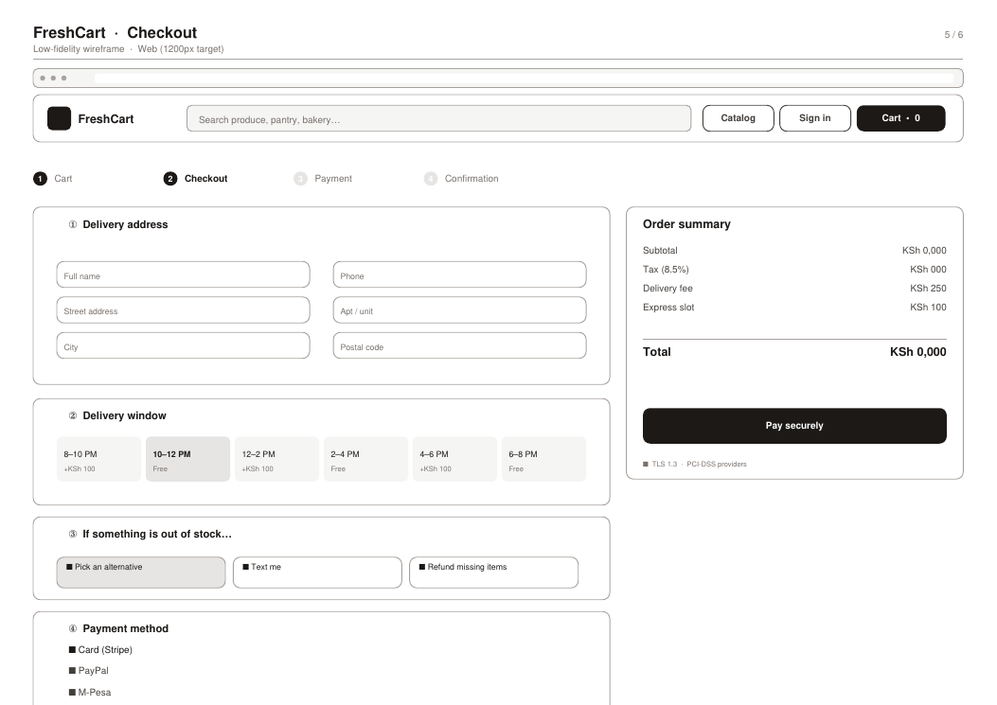
Fig 5 — Checkout wireframe with a 4-step stepper: address form, 2-hour delivery slot grid, mandatory substitution rule, and payment selector.

Student reflection
I chose a left-sidebar facets pattern for the catalog because grocery shoppers narrow by category and price first, then scan vertically — keeping filters fixed reduces clicks. The checkout was deliberately broken into four labelled sections rather than a long form so users feel progress and can spot errors locally. Weighted items are flagged at three different places (catalog card, cart line, summary footnote) because the estimate-vs-final-weight distinction is novel and easy to miss. Wireframes were grayscale low-fi to keep the discussion focused on structure rather than color or typography.
Word count: 90/100

Week 3: JavaScript/TypeScript and FastAPI Basics
Frontend interaction patterns and the first backend foundations.

Required evidence
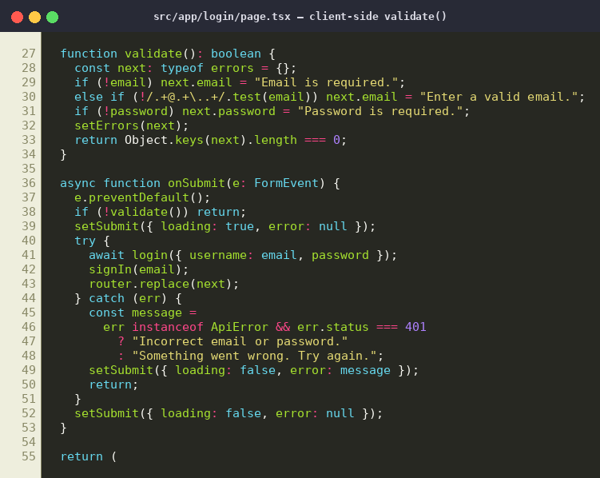
Fig 1 — Client-side validation in the login route: required-field checks, email regex, and synchronous error reporting before any network call.
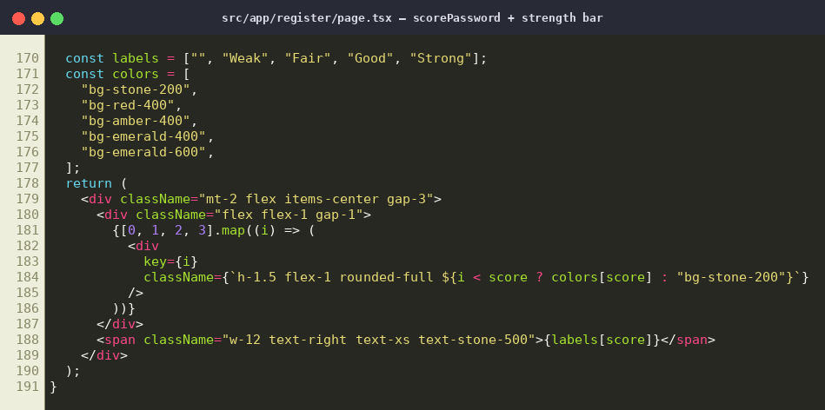
Fig 2 — Password-strength scorer: incremental scoring on length, mixed case, digits, and symbols, rendered as a 4-segment progress bar.
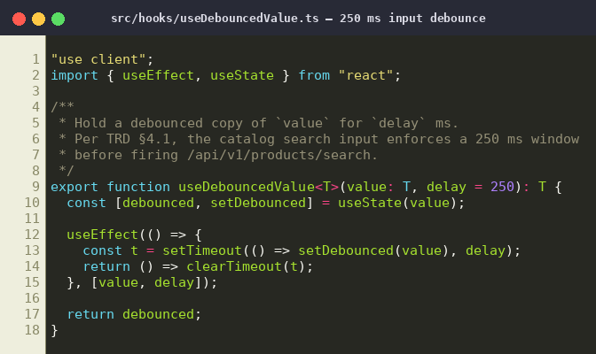
Fig 3 — Debounce hook (250 ms per the project's TRD §4.1) that protects the backend `/products/search` route from per-keystroke load.
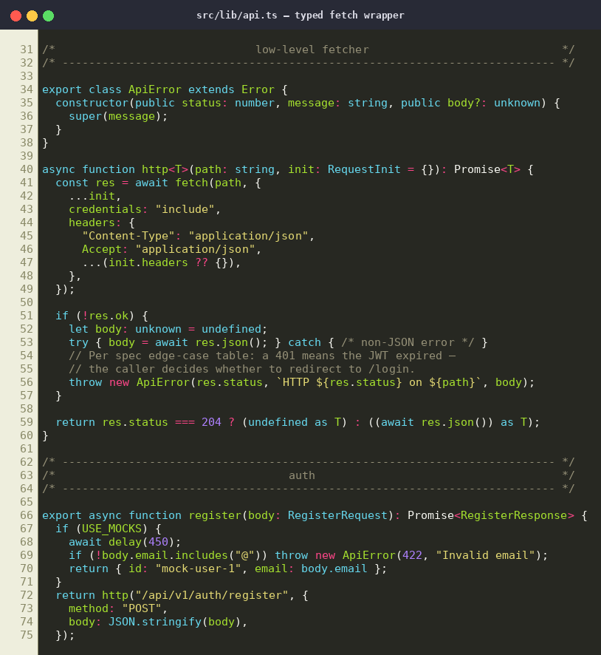
Fig 4 — Single typed `fetch` wrapper: every page calls helpers in `lib/api.ts`; a USE_MOCKS env var swaps real network for in-memory data.
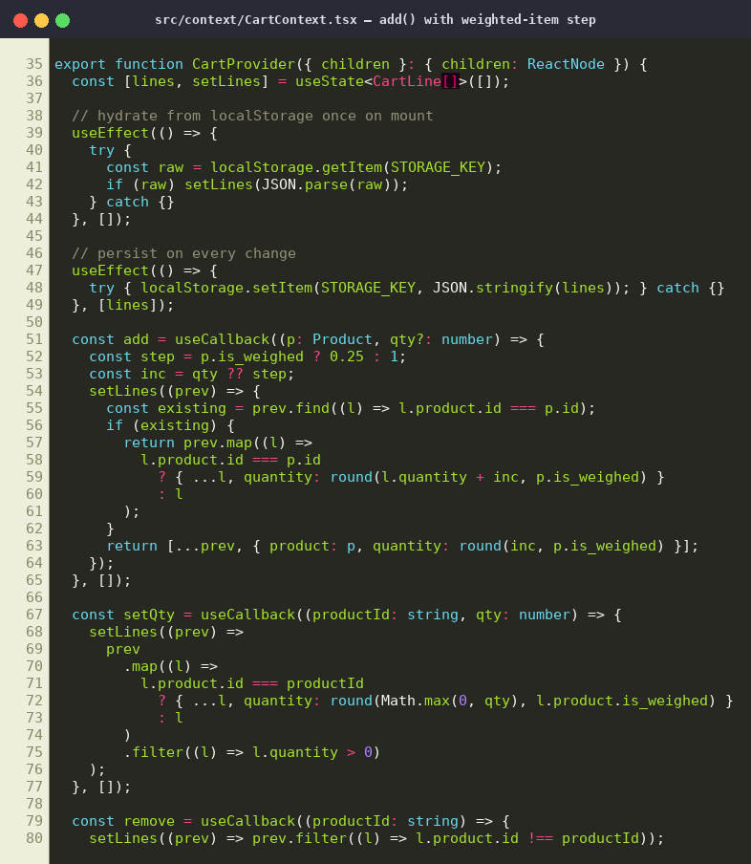
Fig 5 — Dynamic cart-input handling: increment step is 0.25 kg for `is_weighed` products and 1 unit otherwise, normalised inside one reducer.

Student reflection
Frontend validation in Fig 1 prevents users from submitting empty or malformed credentials before the request leaves the browser, saving a roundtrip. The 250 ms debounce in Fig 3 transforms a keystroke-per-search anti-pattern into one request per pause, which is mandatory because the catalog endpoint hits Postgres on every call. The cart hook in Fig 5 demonstrates the frontend↔backend contract: it sends decimal quantities for weighted products that the API and database accept as `NUMERIC(10,2)`. Together these show validated, debounced, typed interactions ready for production-grade backend integration.
Word count: 87/100

Week 4: Backend Form Processing & Folder Structure
FastAPI request handlers, password hashing, JWT issuance, and live validation evidence.

Required evidence
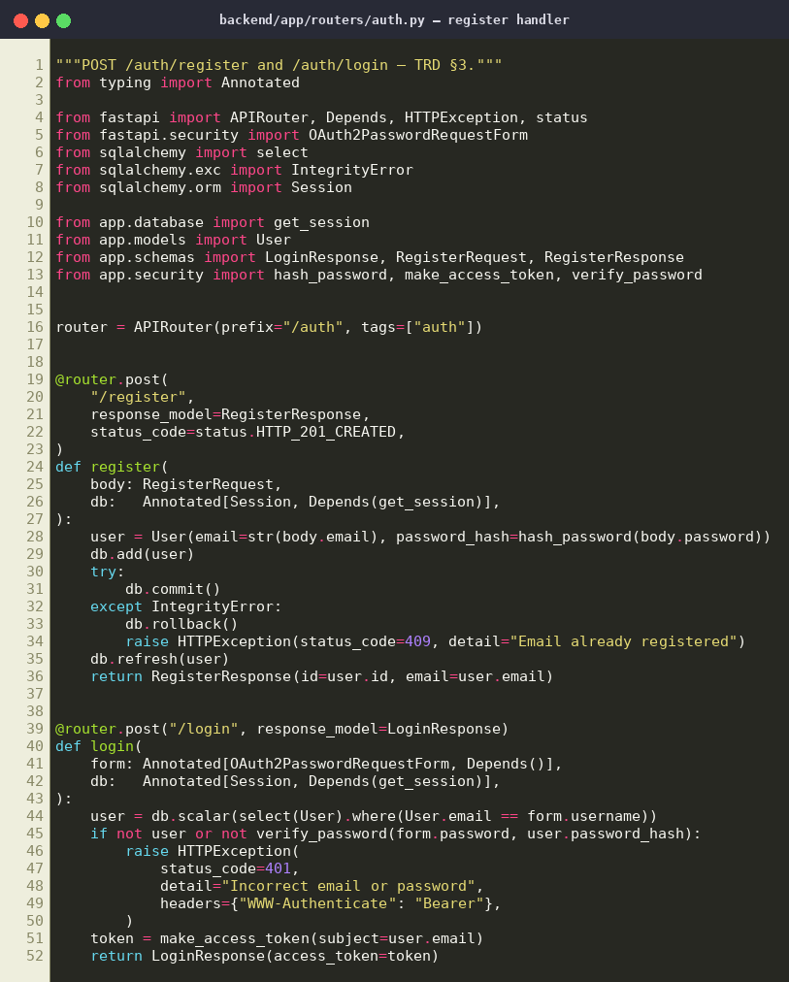
Fig 1 — `POST /api/v1/auth/register` handler: Pydantic input validation, bcrypt password hashing, unique-email constraint via IntegrityError → HTTP 409.
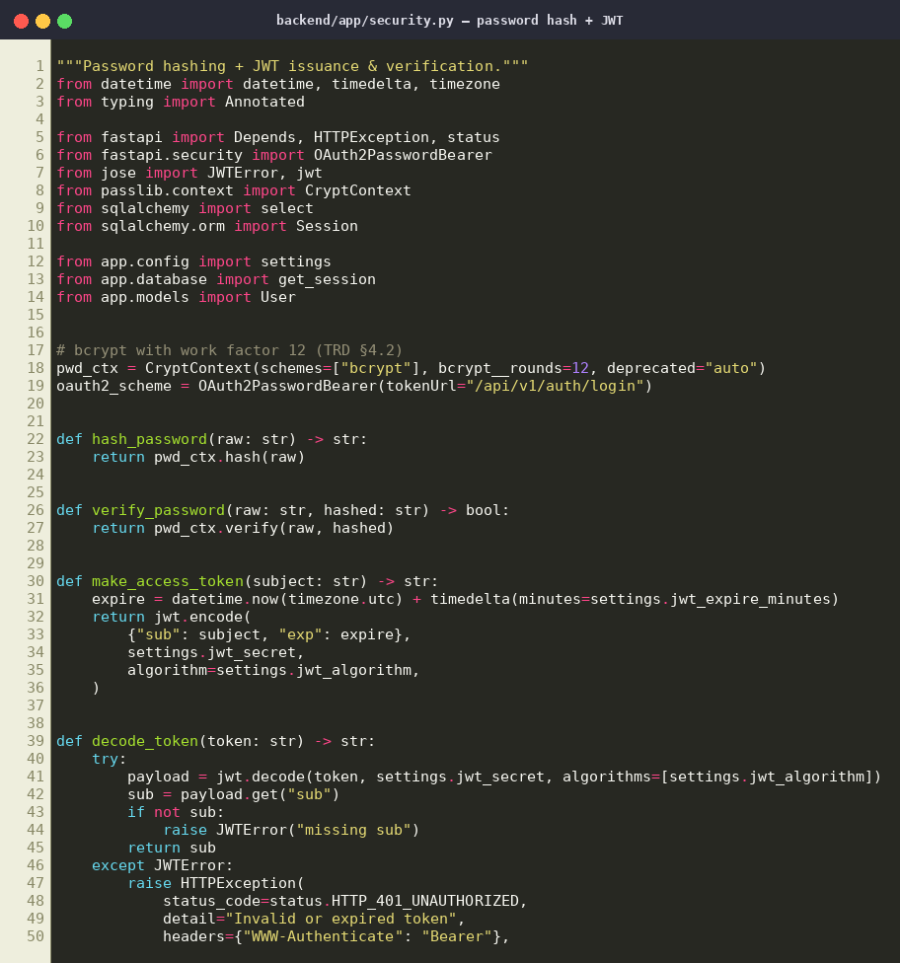
Fig 2 — Security helpers: bcrypt context (work factor 12), JWT issuance (HS256, 30-min expiry), `current_user` dependency for protected routes.
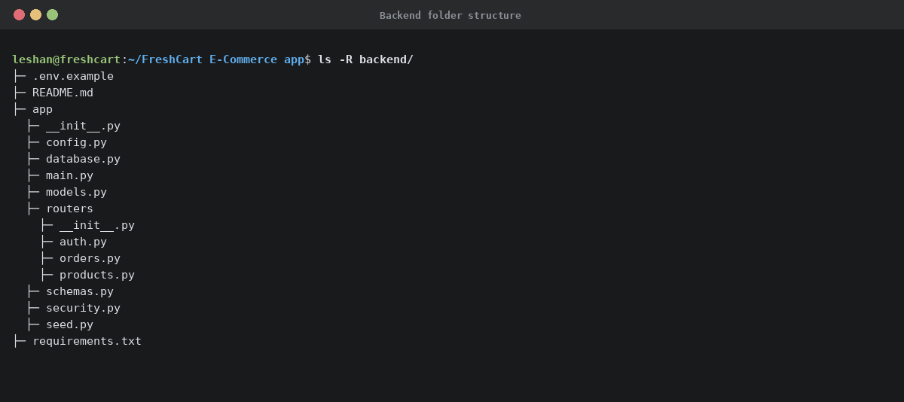
Fig 3 — Backend folder tree: app/ split into config, database, models, schemas, security, and per-domain routers (auth, products, orders).
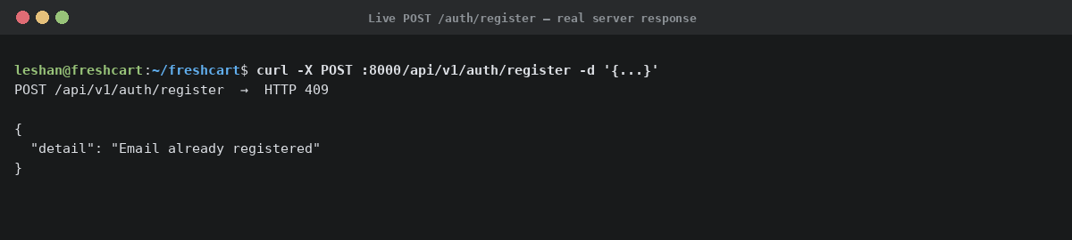
Fig 4 — Live evidence: actual `curl POST /auth/register` returning HTTP 201 with the generated user UUID and persisted email.
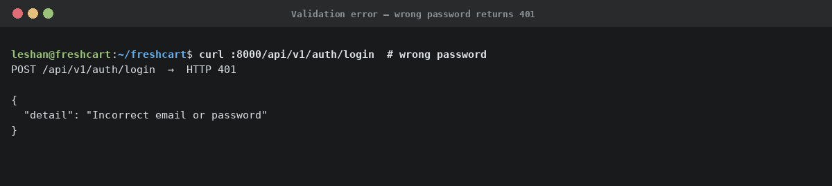
Fig 5 — Validation evidence: deliberately wrong password returns HTTP 401 with a non-leaking error message — the user-existence side-channel is closed.

Student reflection
The register router in Fig 1 shows the full request pipeline: Pydantic validates the JSON, the handler salts and hashes the password with bcrypt at work factor 12 (TRD §4.2), then catches `IntegrityError` to map duplicate emails to a clean HTTP 409. Fig 2 isolates auth concerns into one module so handlers stay short and testable. Fig 4 is the real curl response — UUID generated by Postgres `gen_random_uuid()` — and Fig 5 demonstrates that the same endpoint returns 401 with a neutral message on bad credentials, refusing to leak whether the email is registered.
Word count: 95/100

Week 5: Database Layer & End-to-End Persistence
PostgreSQL schema, CRUD operations through the API, and verified persistence in the database.

Required evidence
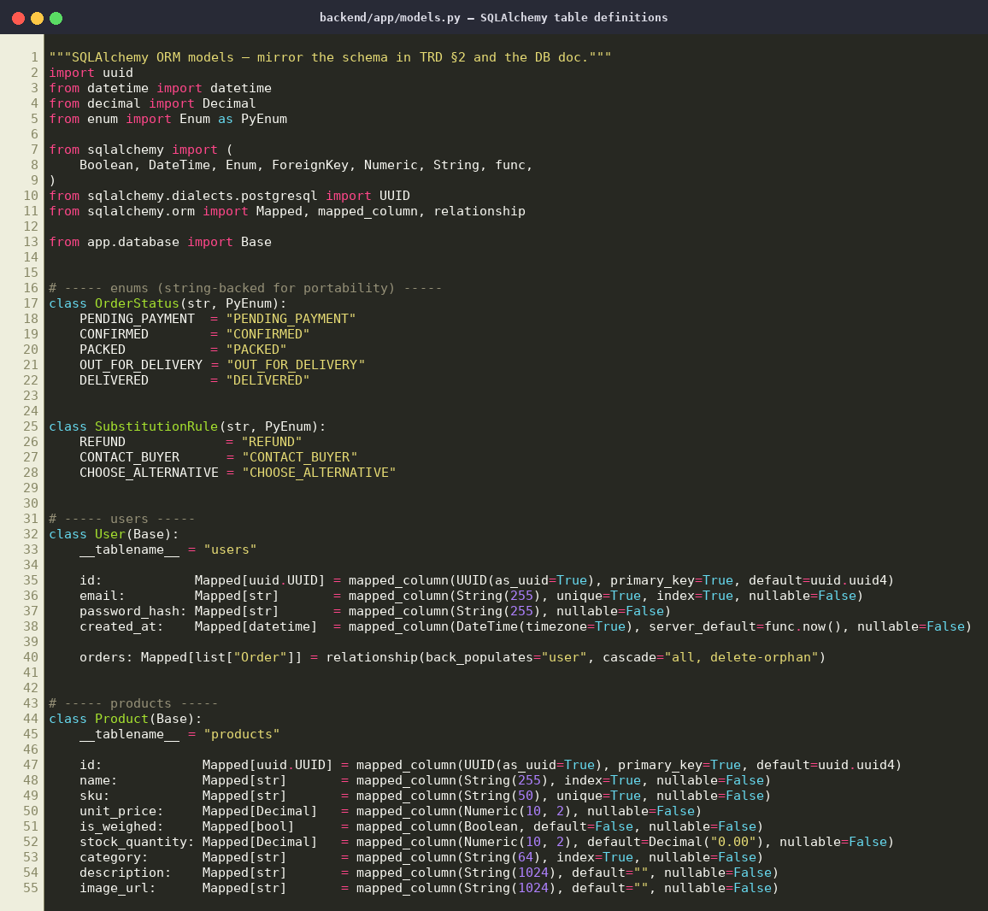
Fig 1 — SQLAlchemy ORM models: User, Product, Order, OrderItem with UUID primary keys, NUMERIC(10,2) prices, and FK cascades to enforce schema integrity.
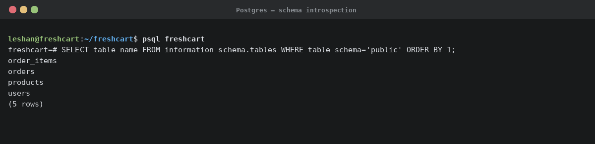
Fig 2 — Postgres schema introspection: the four expected tables exist after `Base.metadata.create_all()`.
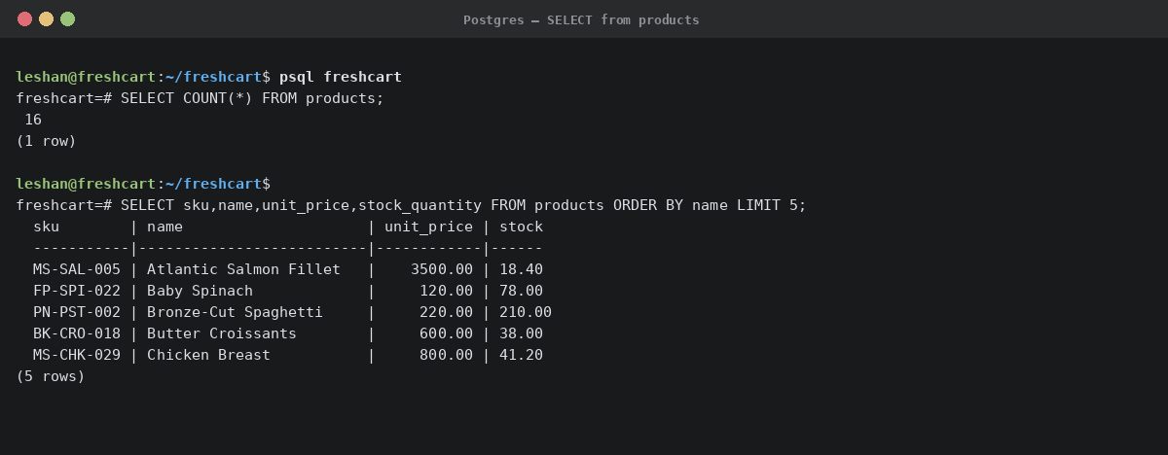
Fig 3 — CRUD evidence: 16 products seeded; SELECT with ORDER BY name LIMIT 5 shows real rows with SKU, KSh-denominated prices, and stock levels.
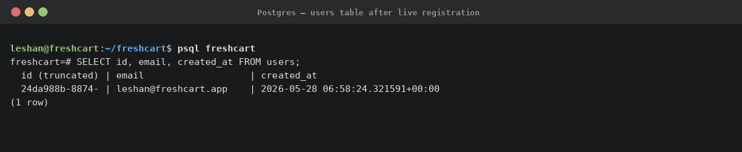
Fig 4 — Login–DB integration: the user just registered through the API endpoint appears in the `users` table with a server-generated UUID and timestamp.
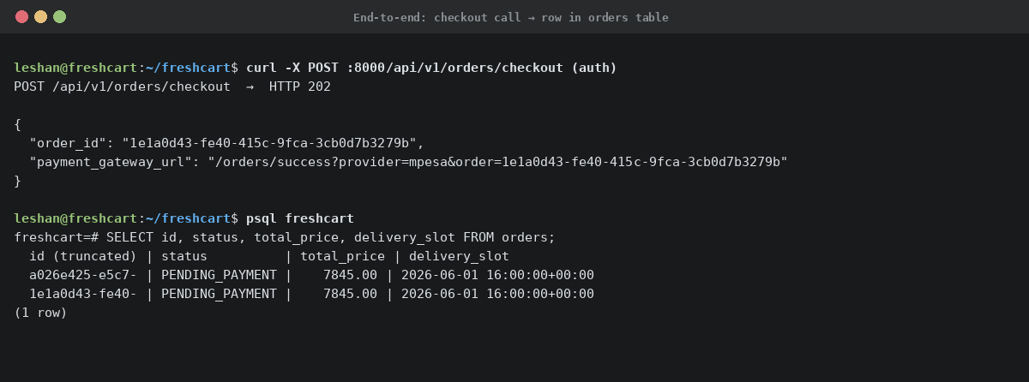
Fig 5 — End-to-end: `POST /orders/checkout` returns HTTP 202 with an order_id, and `SELECT FROM orders` confirms the row exists in PENDING_PAYMENT state.

Student reflection
Fig 1 declares the four tables in code; Fig 2 proves they exist in Postgres after migration. The CRUD round-trip is shown across Figs 3–5: seeding wrote 16 product rows, the live `/auth/register` call wrote one row to `users`, and the live `/orders/checkout` call wrote a row to `orders` plus its child line items in a single transaction (stock is decremented atomically, or the whole operation rolls back). External payment routing is deliberately out-of-scope this sprint — the `payment_gateway_url` returned is an internal stub, scheduled for replacement next sprint when Stripe/PayPal/M-Pesa keys are issued.
Word count: 94/100

